<http://127.0.0.1:5500/Part%202/templates/allTeas.html>

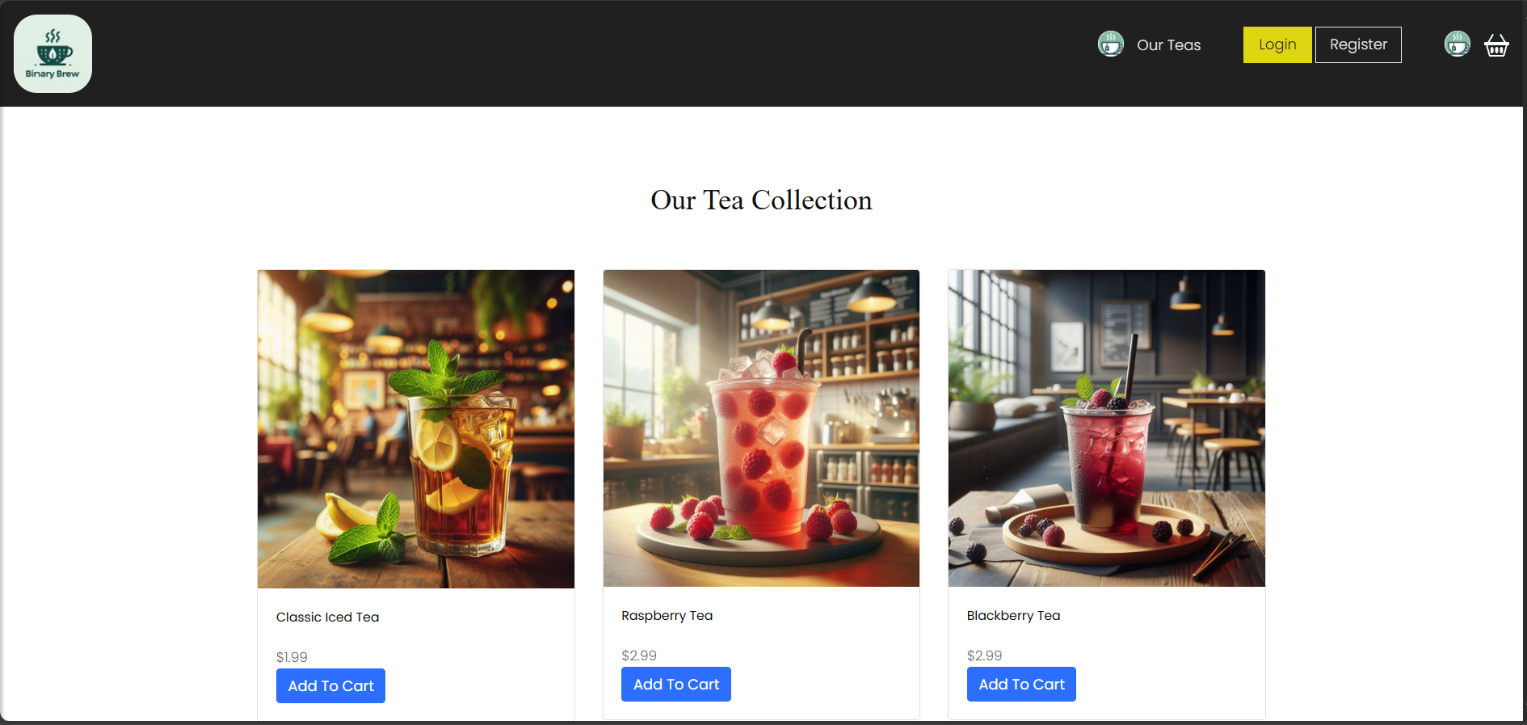

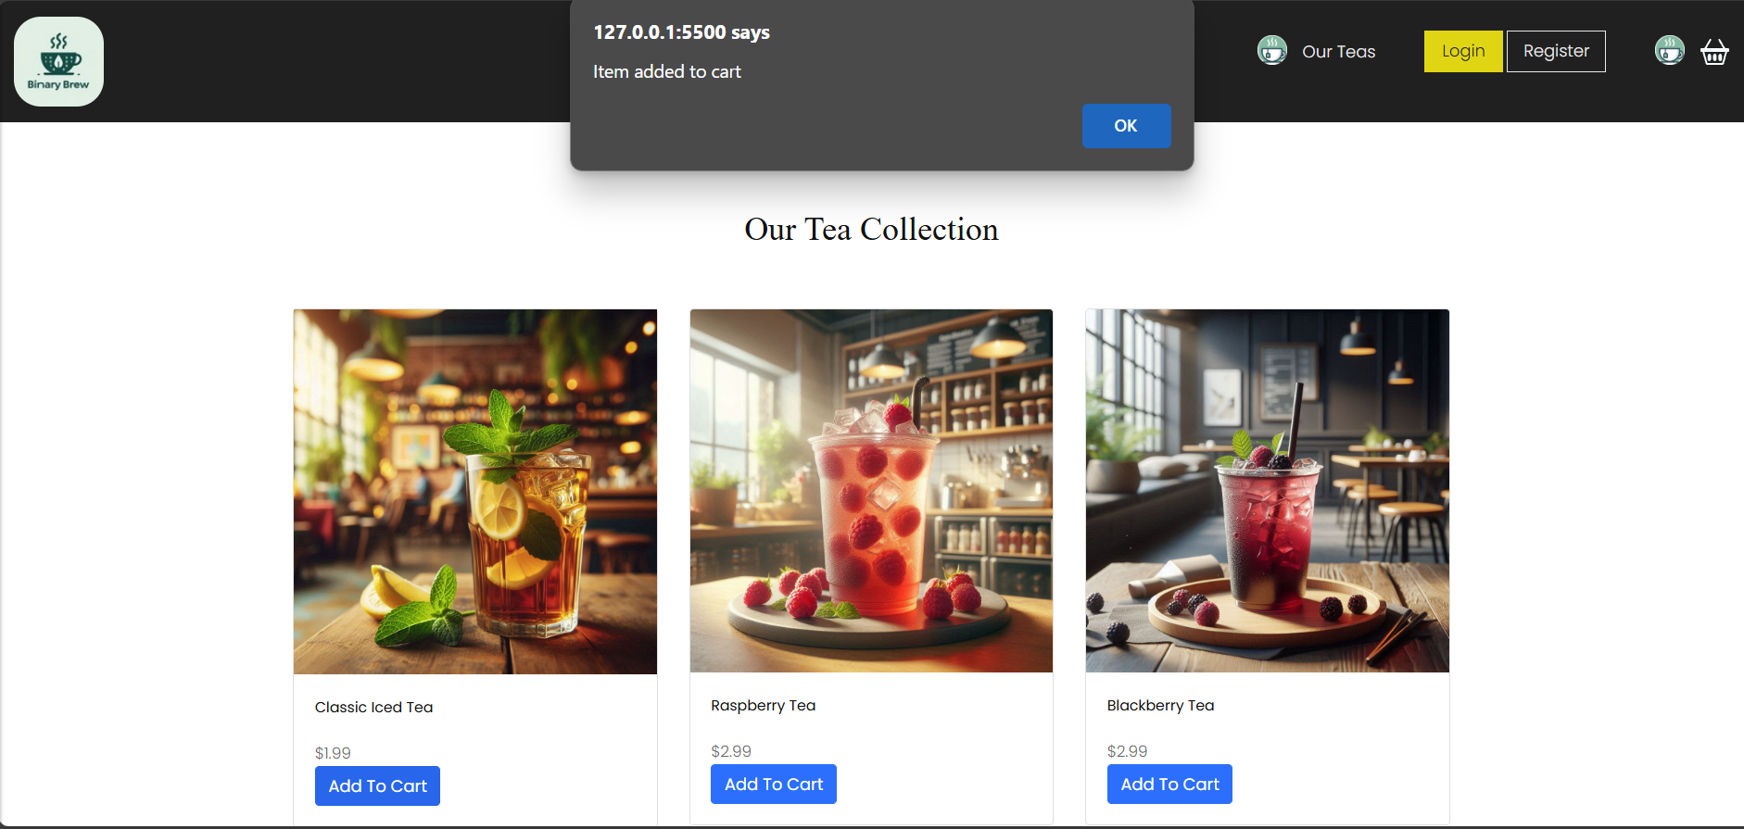

<http://127.0.0.1:5500/Part%202/templates/cart.html>

